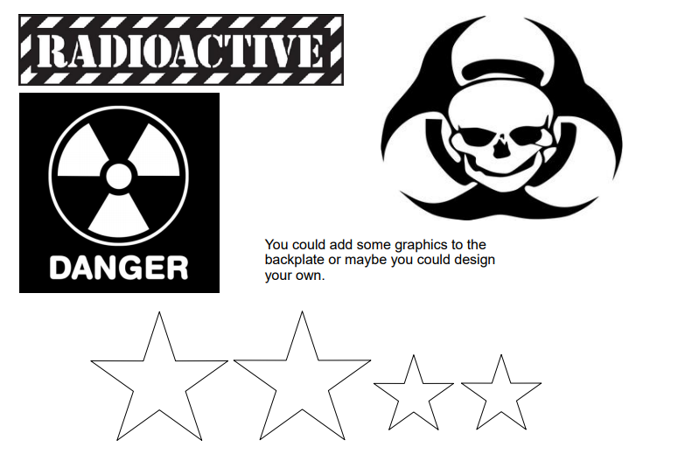
Download and print the graphics to add to your Cosmic Jetpack!

